AZ 204 Labworks

Deploy a WebApp Service

Kaushik Ganguli

Contents

Deploy an App Service from Portal 2

Create Resource Group, WebApp Plan and WebApp Service 2

Verify the creation of the WebApp Service 4

Deploy WebApp Service using CLI 5

Create the Resource Group 5

Create a WebApp Plan 5

Create the WebApp Service 6

Deploy the WebApp 6

Test the Deployment 6

Deploy WebApp Service from PowerShell 7

Create the Resource Group 7

Create the WebApp Plan 7

Create the WebApp Service 7

Deploy the WebApp 8

Test the WebApp 8

Delete all resources 8

# Deploy an App Service from Portal

## Create Resource Group, WebApp Plan and WebApp Service

Login to portal.azure.com

Search for App Services

Click on Create

If you don’t have a resource group, it will ask you to create one:

Continuing to the AppService, I’ve entered .NET 3.5 as the runtime environment and the OS as Windows.

The plan chosen is Free F1

In Deployment tab, the continuous deployment is Disabled

In Monitor screen, no monitoring is needed.

In the Review + Create screen, click on ‘Download a template for automation’ to download the JSON file

Download the file locally. The downloaded ZIP contains two JSON files – one for template and one for the parameters

## Verify the creation of the WebApp Service

Go back to the Create WebApp page and click on Create. Refresh the page after a few seconds and the AppService is ready

# Deploy WebApp Service using CLI

## Create the Resource Group

webappname=mywebapp$RANDOM

az group create --location westeurope --name myResourceGroup

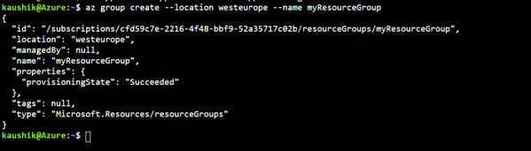

## Create a WebApp Plan

az appservice plan create --name KaushikWebApp13112021_1 --resource-group myResourceGroup --sku FREE

## Create the WebApp Service

az webapp create --name $webappname --resource-group myResourceGroup --plan $webappname

## Deploy the WebApp

gitrepo=https://github.com/Azure-Samples/php-docs-hello-world

az webapp deployment source config --name $webappname --resource-group myResourceGroup --repo-url $gitrepo --branch master --manual-integration

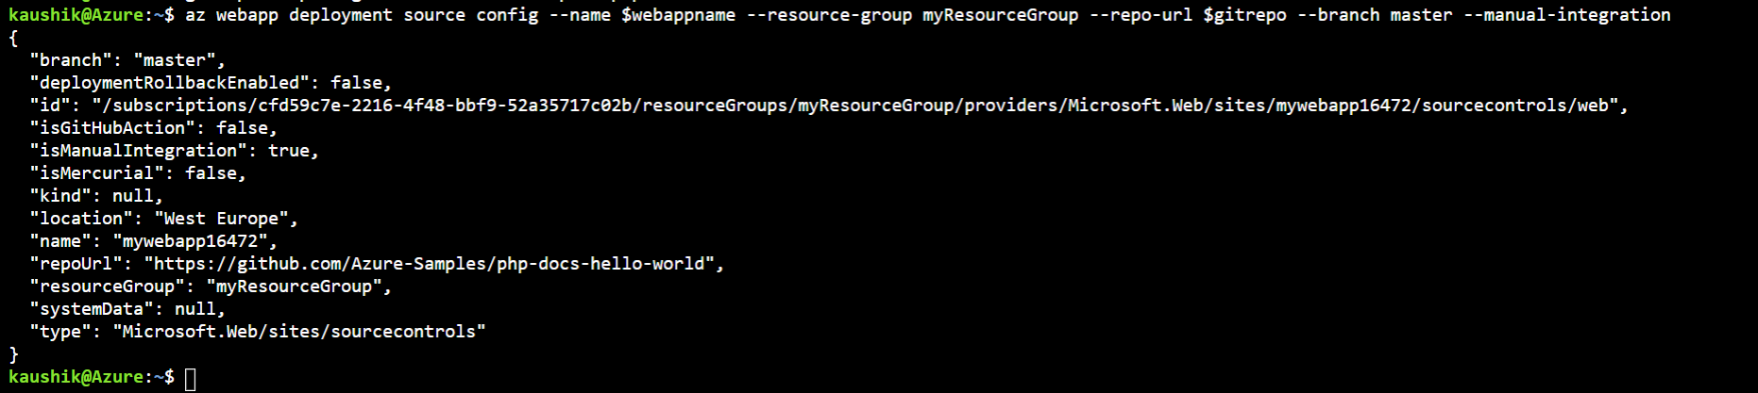

## Test the Deployment



Click on the link to open the URL

# Deploy WebApp Service from PowerShell

## Create the Resource Group

$webappname="mywebapp$(Get-Random)"

$location="West Europe"

New-AzResourceGroup -Name myResourceGroup -Location $location

It prompted for Confirmation since the Resource Group already existed from the CLI deployment done earlier

## Create the WebApp Plan

New-AzAppServicePlan -Name $webappname -Location $location -ResourceGroupName myResourceGroup -Tier Free



## Create the WebApp Service

New-AzWebApp -Name $webappname -Location $location -ResourceGroupName myResourceGroup -AppServicePlan $webappname

## Deploy the WebApp

$gitrepo=https://github.com/Azure-Samples/app-service-web-dotnet-get-started.git

$PropertiesObject=@{

repoUrl = "$gitrepo";

branch="master";

isManualIntegration = "true";

}

Set-AzResource -PropertyObject $PropertiesObject -ResourceGroupName myResourceGroup -ResourceType Microsoft.Web/sites/sourcecontrols -ResourceName $webappname/web -ApiVersion 2015-08-01 -Force

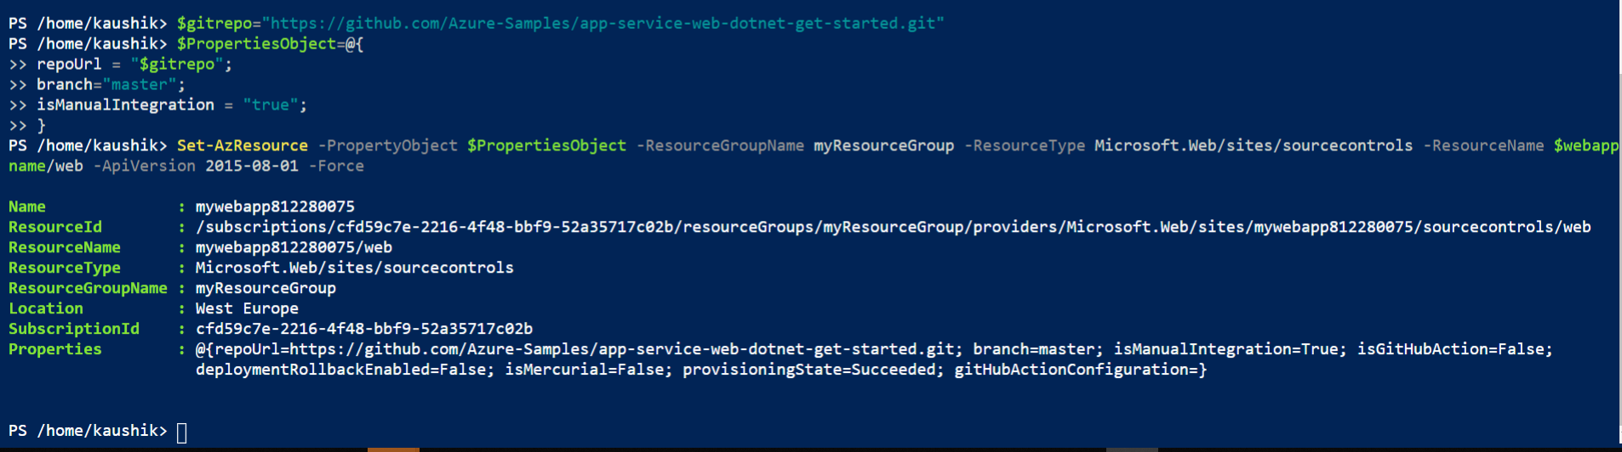

## Test the WebApp

https://mywebapp812280075.azurewebsites.net/

# Delete all resources

Go to All Resources 🡪 Select all resources created for the lab 🡪 Delete